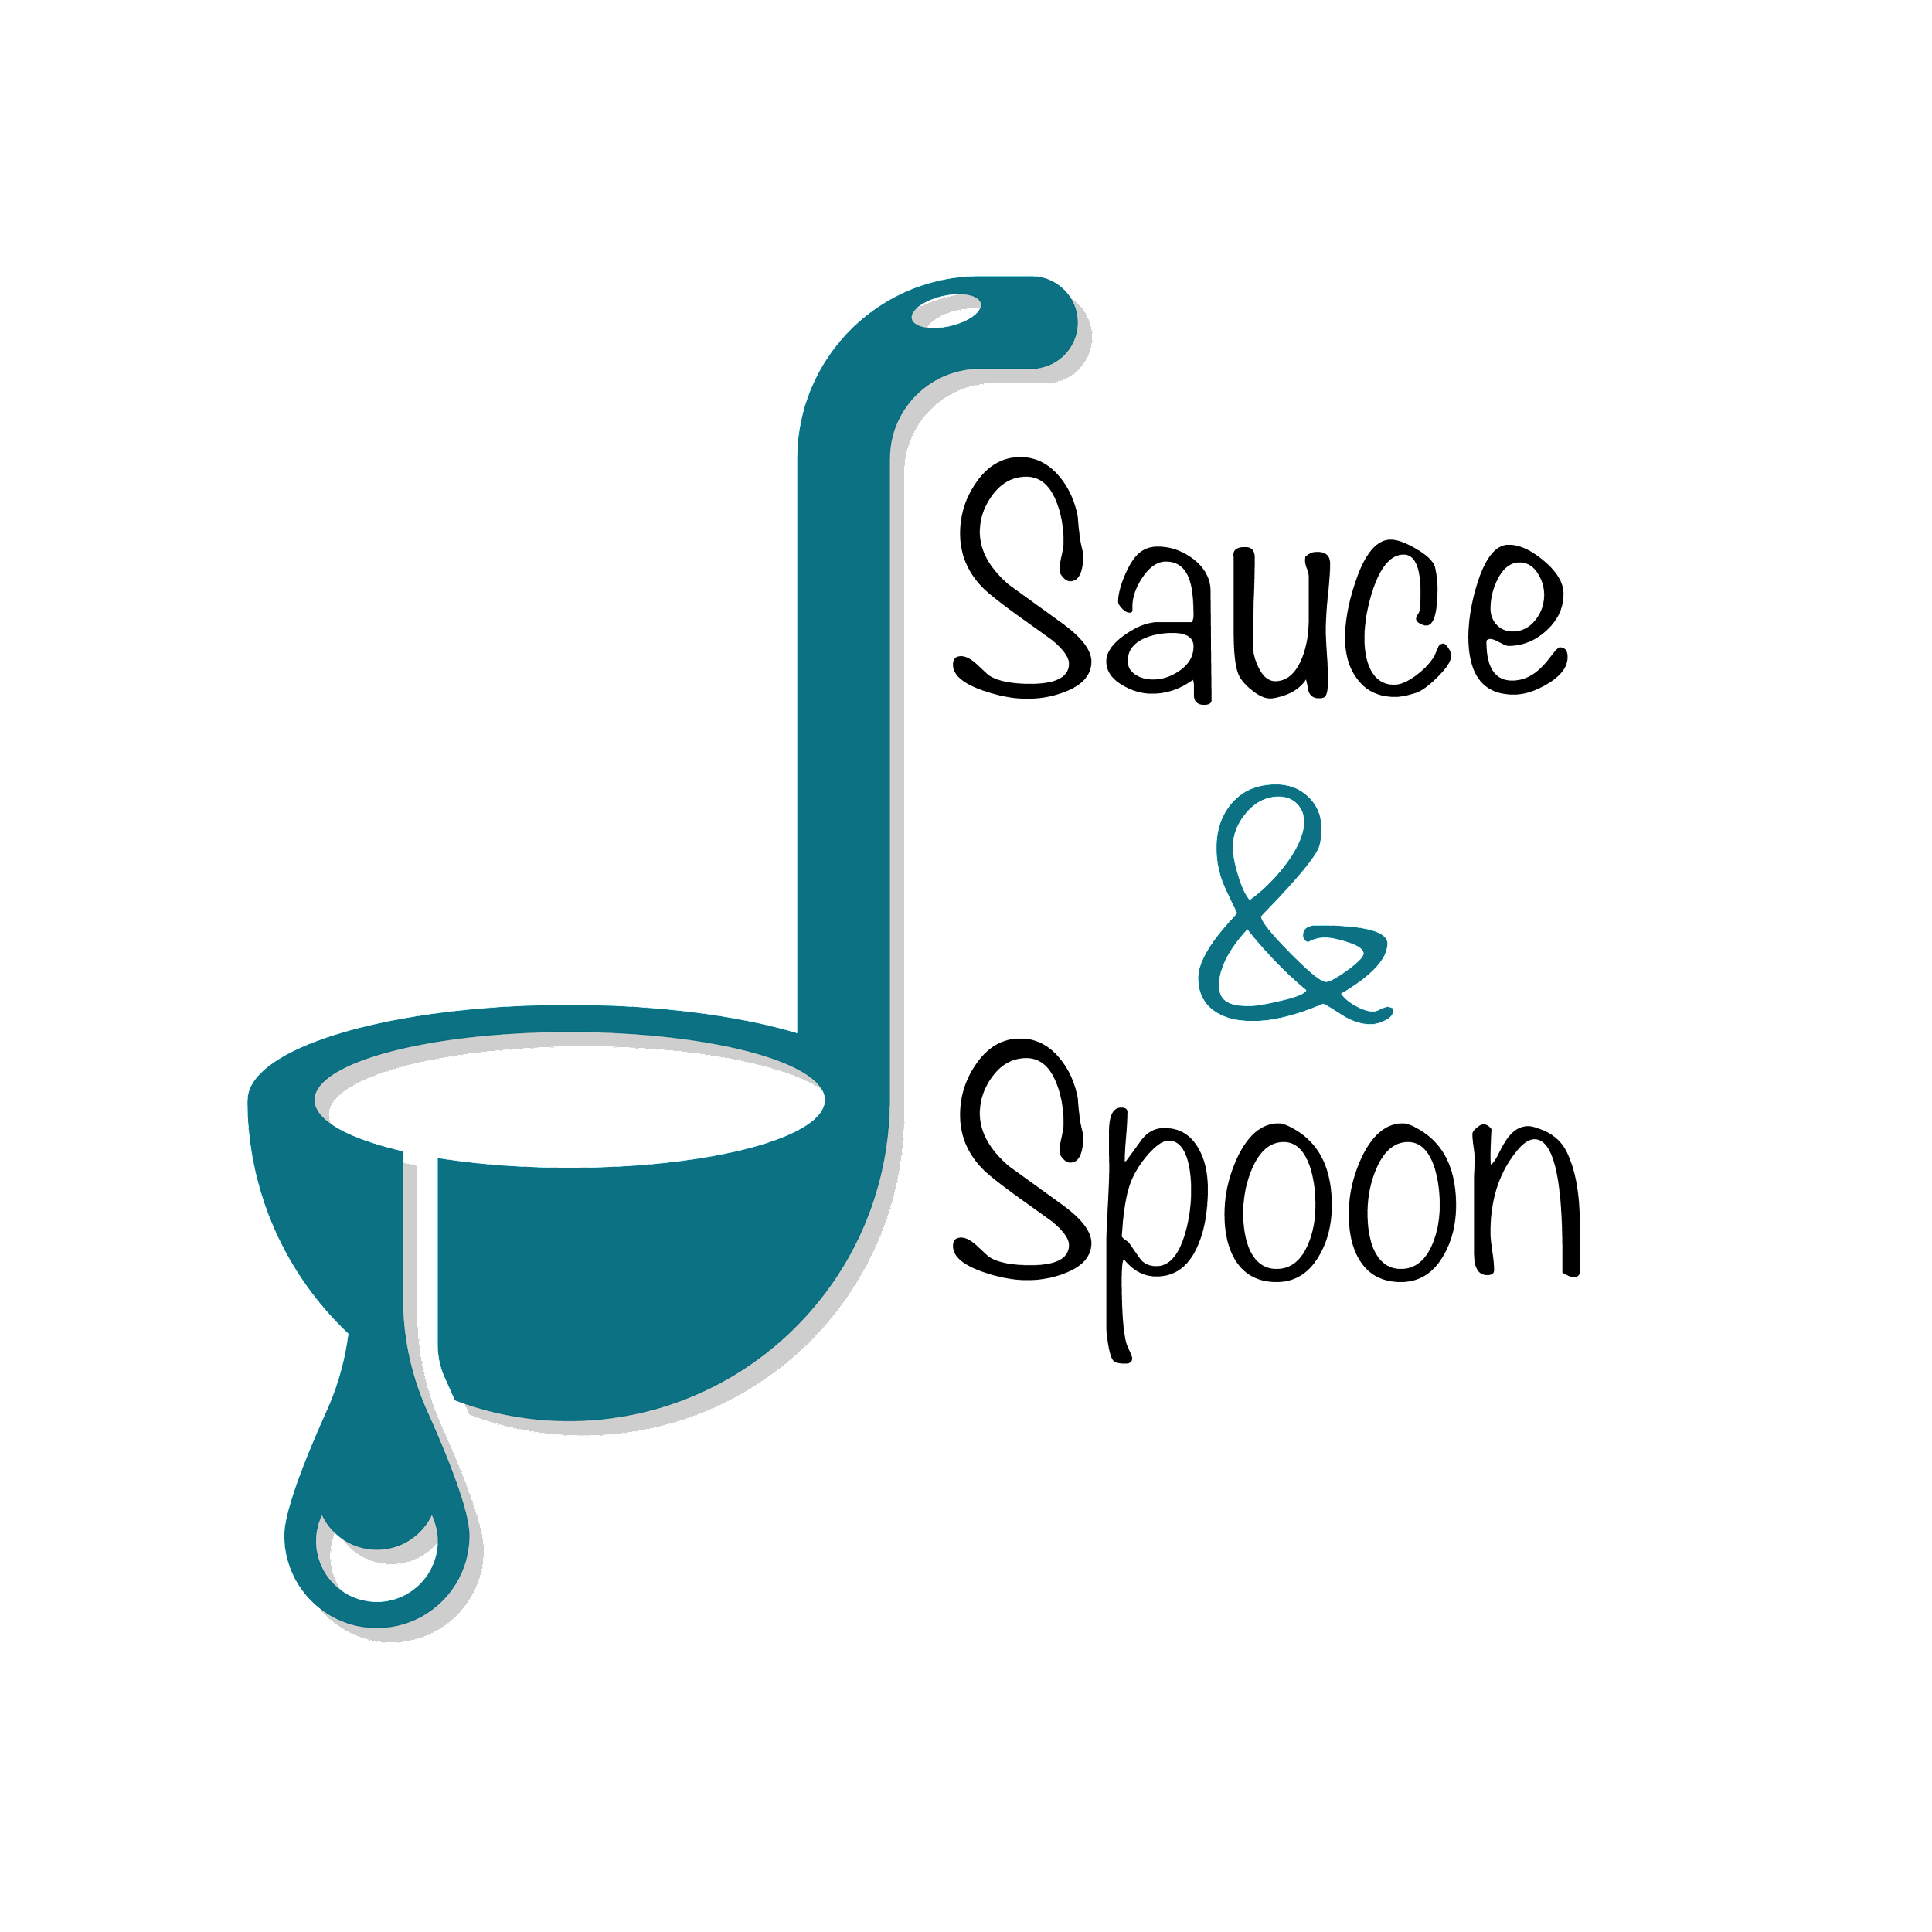

Project Charter: [**tabletop menu tablets**]

DATE: [10/09/23]

| **Project Summary** |
| --- |
| Sauce & Spoon would like to launch a pilot rollout of tabletop menu tablets at two of their restaurant locations, Sauce & Spoon North and Sauce & Spoon Downtown. That way, guests can place their orders on the tablets as soon as they arrive at the restaurant, rather than waiting for a server to attend to them, which has been an issue in the past. |

| **Project Goals** |
| --- |
| * increase of product mix * decrease of average table turn time by 30 minutes by the end of June * Cut food waste by 25% by the end of June * 15% increase appetizers sales by the end of June * selling more specialty drinks * reallocate some of the payroll from our FOH budget to hire more cooks * increased average check value from 65 to 75$ by the end of June * Increase daily guest counts by 10% by the end of June * improving the satisfaction of the kitchen staff * Decrease employee burnout and turnover |

| **Deliverables** |
| --- |
| * Tabletop Menu Tablets: Implement user-friendly tabletop tablets with interactive menus. * Item Add-On and Coupons Feature: Incorporate features for item add-ons and coupons into the menu. * Training Plan: Develop and implement a comprehensive training plan for staff regarding the new system. * Product Mix: Expand the product mix to offer a wider variety of menu items. * Reduced Burnout: Address and mitigate staff burnout concerns. * Reduced Employee Turnover: Take measures to reduce employee turnover. * Increased Efficiency: Implement changes aimed at improving overall operational efficiency. * Enhanced Customer Experience: Enhance the overall customer dining experience. |

| **Scope and Exclusion** |
| --- |
| **In-Scope:**   * tablet rollout only in the bar area * Ensuring a positive customer experience. * Reducing food waste. * Increasing sales. * Expanding and diversifying the product mix.   **Out-of-Scope:**   * expand the tablet rollout to include all of the restaurant dining sections * Change in the return policy |

| **Benefits & Costs** |
| --- |
| **Benefits:**   * Introduction of tabletop tablets for easier and quicker customer ordering. * Well-trained staff to support tablet implementation. * Improved guest experience, resulting in higher customer ratings and increased satisfaction. * Troubleshooting support for maintaining and resolving issues with the new tablets.   **Costs:**   * IT maintenance fees: $5,000 * Website update and new menu design fee: $5,000 * Training requirements fees: $10,000 * Hardware and software implementation costs: $30,000 * Customization fees: $550 |

| **Appendix:** |
| --- |
| Misalignments:   * Tying the average check total goal to a specific metric, aiming to increase the average total from $65 to $75. * Reallocating payroll for new hires in the kitchen staff contingent upon new data regarding table turn time and revenue changes after tablet introduction. * Setting different appetizer sales goals based on location, targeting a 10% increase in the north locations and a 20% increase in the Downtown location. * Deciding that any change in the return policy should be considered out-of-scope for this project. |